

# Objectives:

1. Linux Filesystem and getting help in Linux
2. Basic Shell Commands

**Task 01:**

# Lab – 02

**Man Pages**

Use the Man pages on the following commands and try to figure out what they do.

1. Id

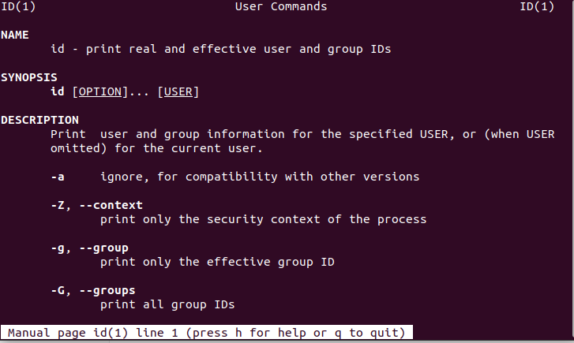

1. uname –r

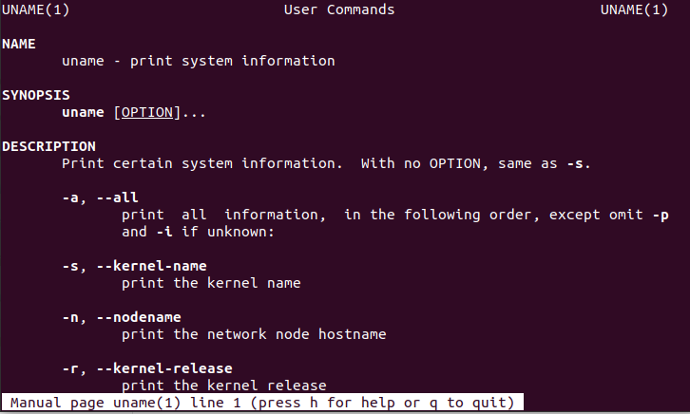

1. whoami

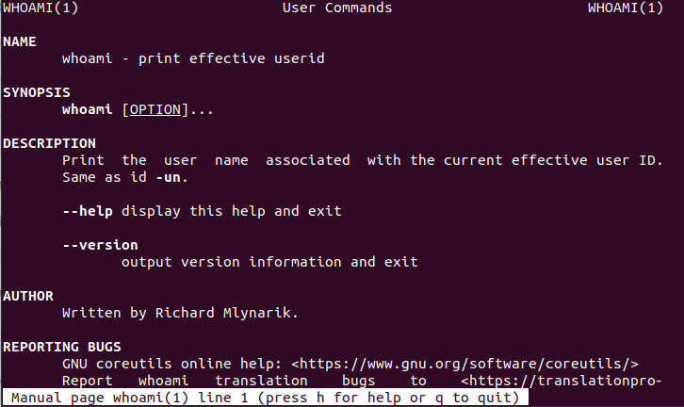

1. ls –l

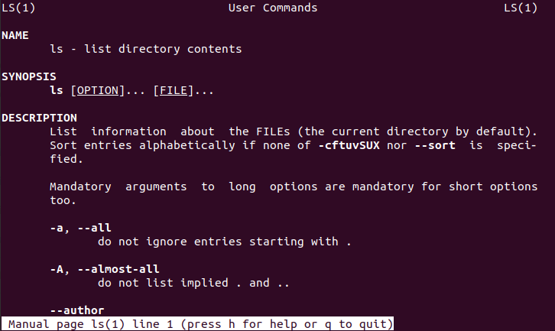

1. ifconfig

Requires external library to install



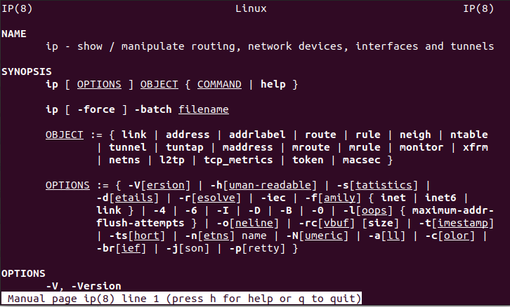

Alternative to ifconfig (man ip)

## Task 02:

Man pages are divided in 9 sections. There is command called “**write**” and well known system call “**ssize_t write (int fd, const void *buf, size_t count);**” how can I open up their respective man pages?

man 1 write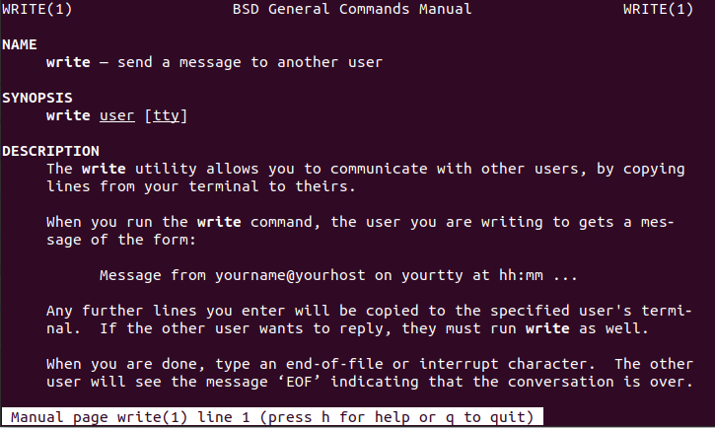

man 2 write

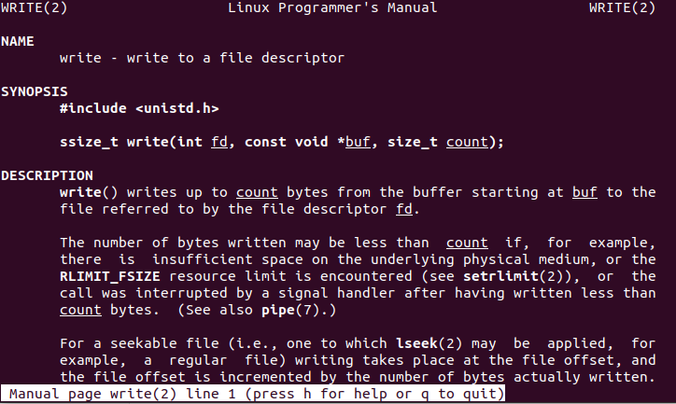

## Task 03:

Using man command try to figure out what is inside the file **/etc/passwd**.

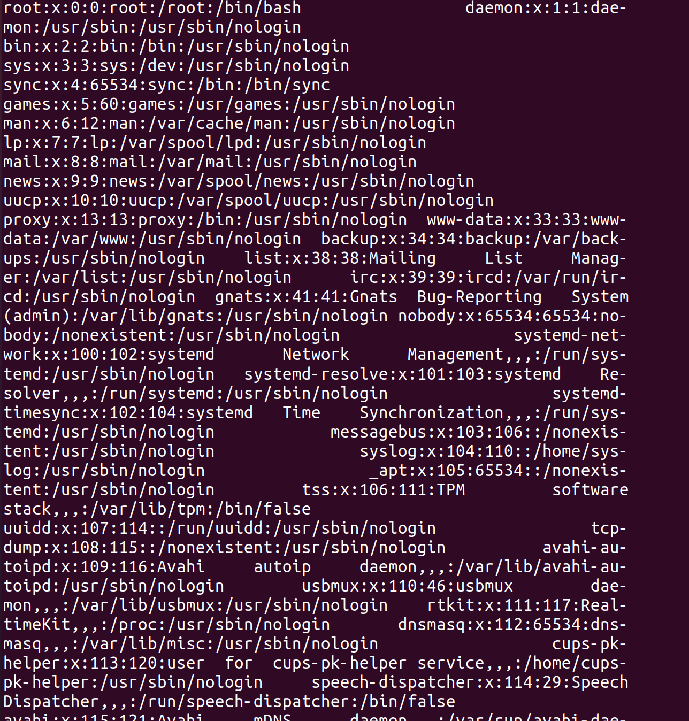

**Task 01:**

# Linux Environment

Copy the **/etc/passwd** file in your current working directory as **lab1.**

* 1. Sort the file on the basis of the third column (save this result as **third_col**).

sort passwdfile.txt -t ':' -k 3 > third_col.txt

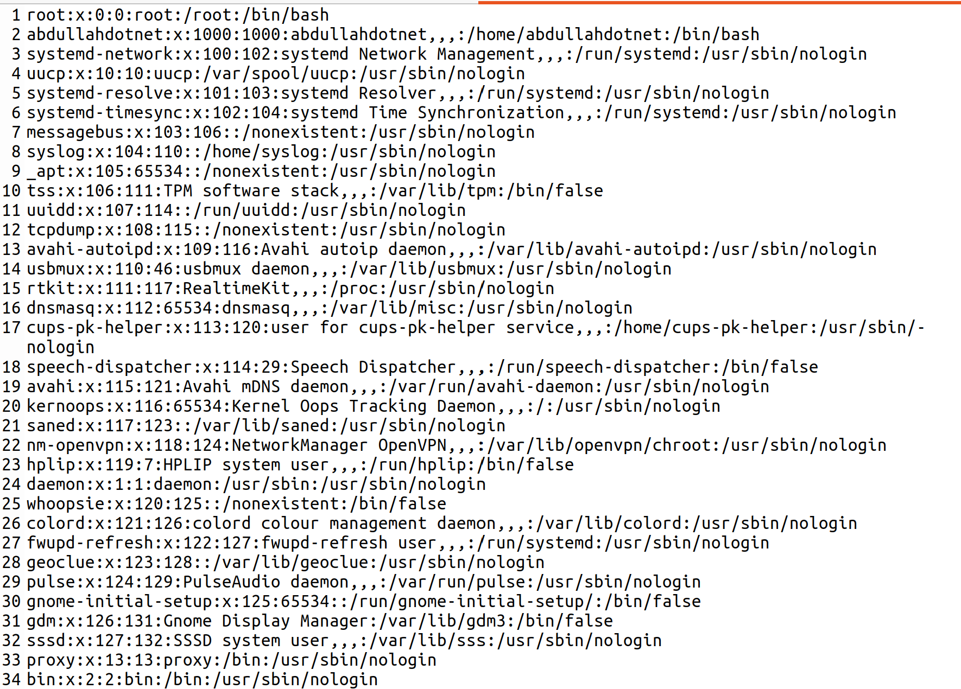

* 1. Sort the file on the basis of the third column but in reverse order (save it as **third_col_r**).

sort passwdfile.txt -t ':' -r -k 3 > third_col_r.txt

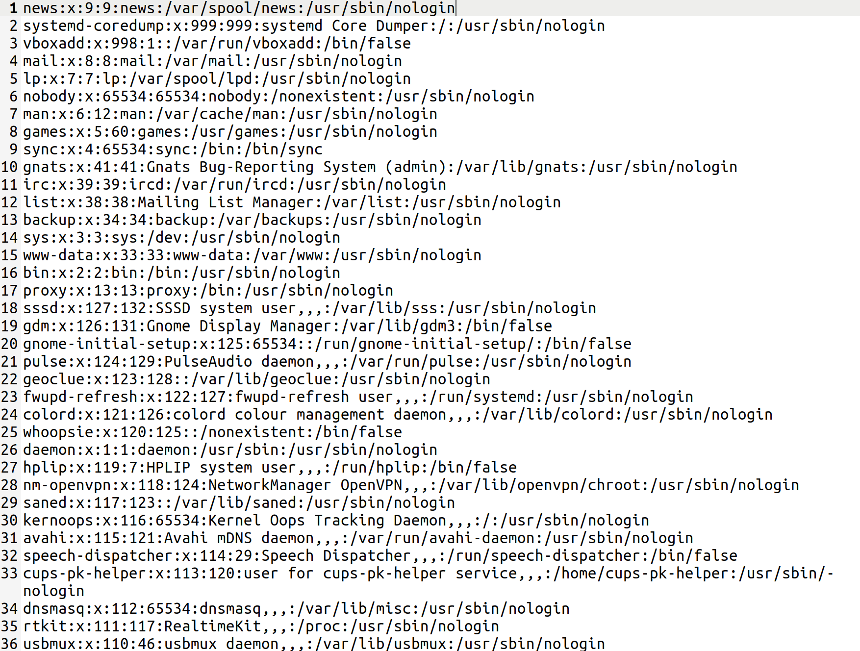

* 1. Try sorting it on the basis of the first column and try using the –n flag (save it as **first_col**).

sort -t ':' -k 1 -n passwdfile.txt > first_col

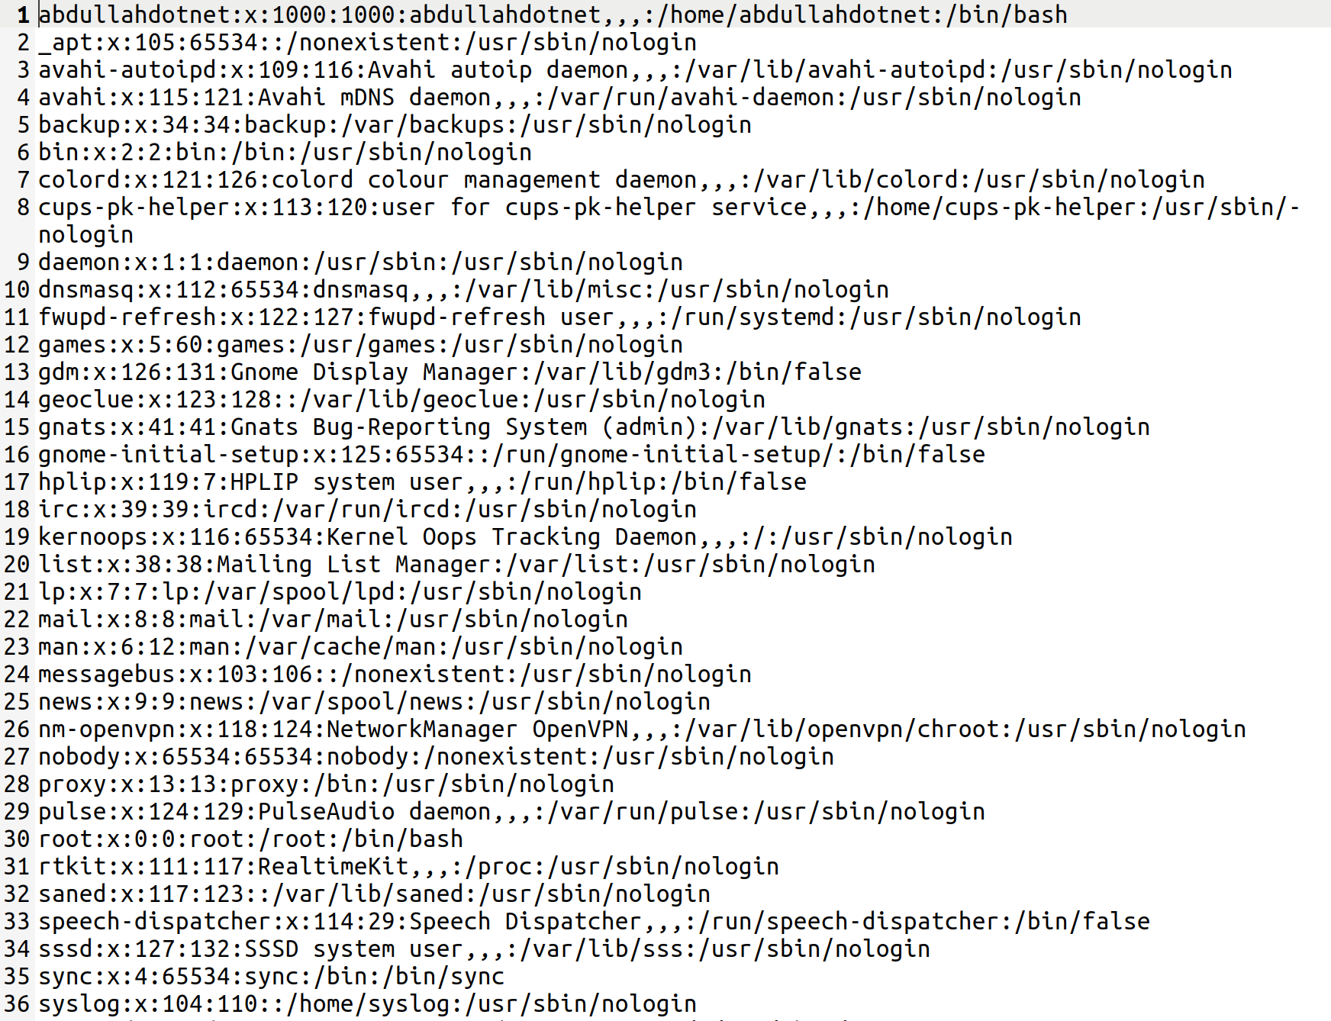

## Task 02:

Perform the following tasks.

1. Use **ls** to find the biggest file in /etc. Also tell how many arguments are in this line.

ls -lS /etc | head -n 1 | wc -w



1. Write the single command to count the number of lines in **/etc/passwd**.

wc -l /etc/passwd



1. Write a single command which reads /etc/passwd and prints only those lines which do not contains string “**root**”

grep -v "root" /etc/passwd

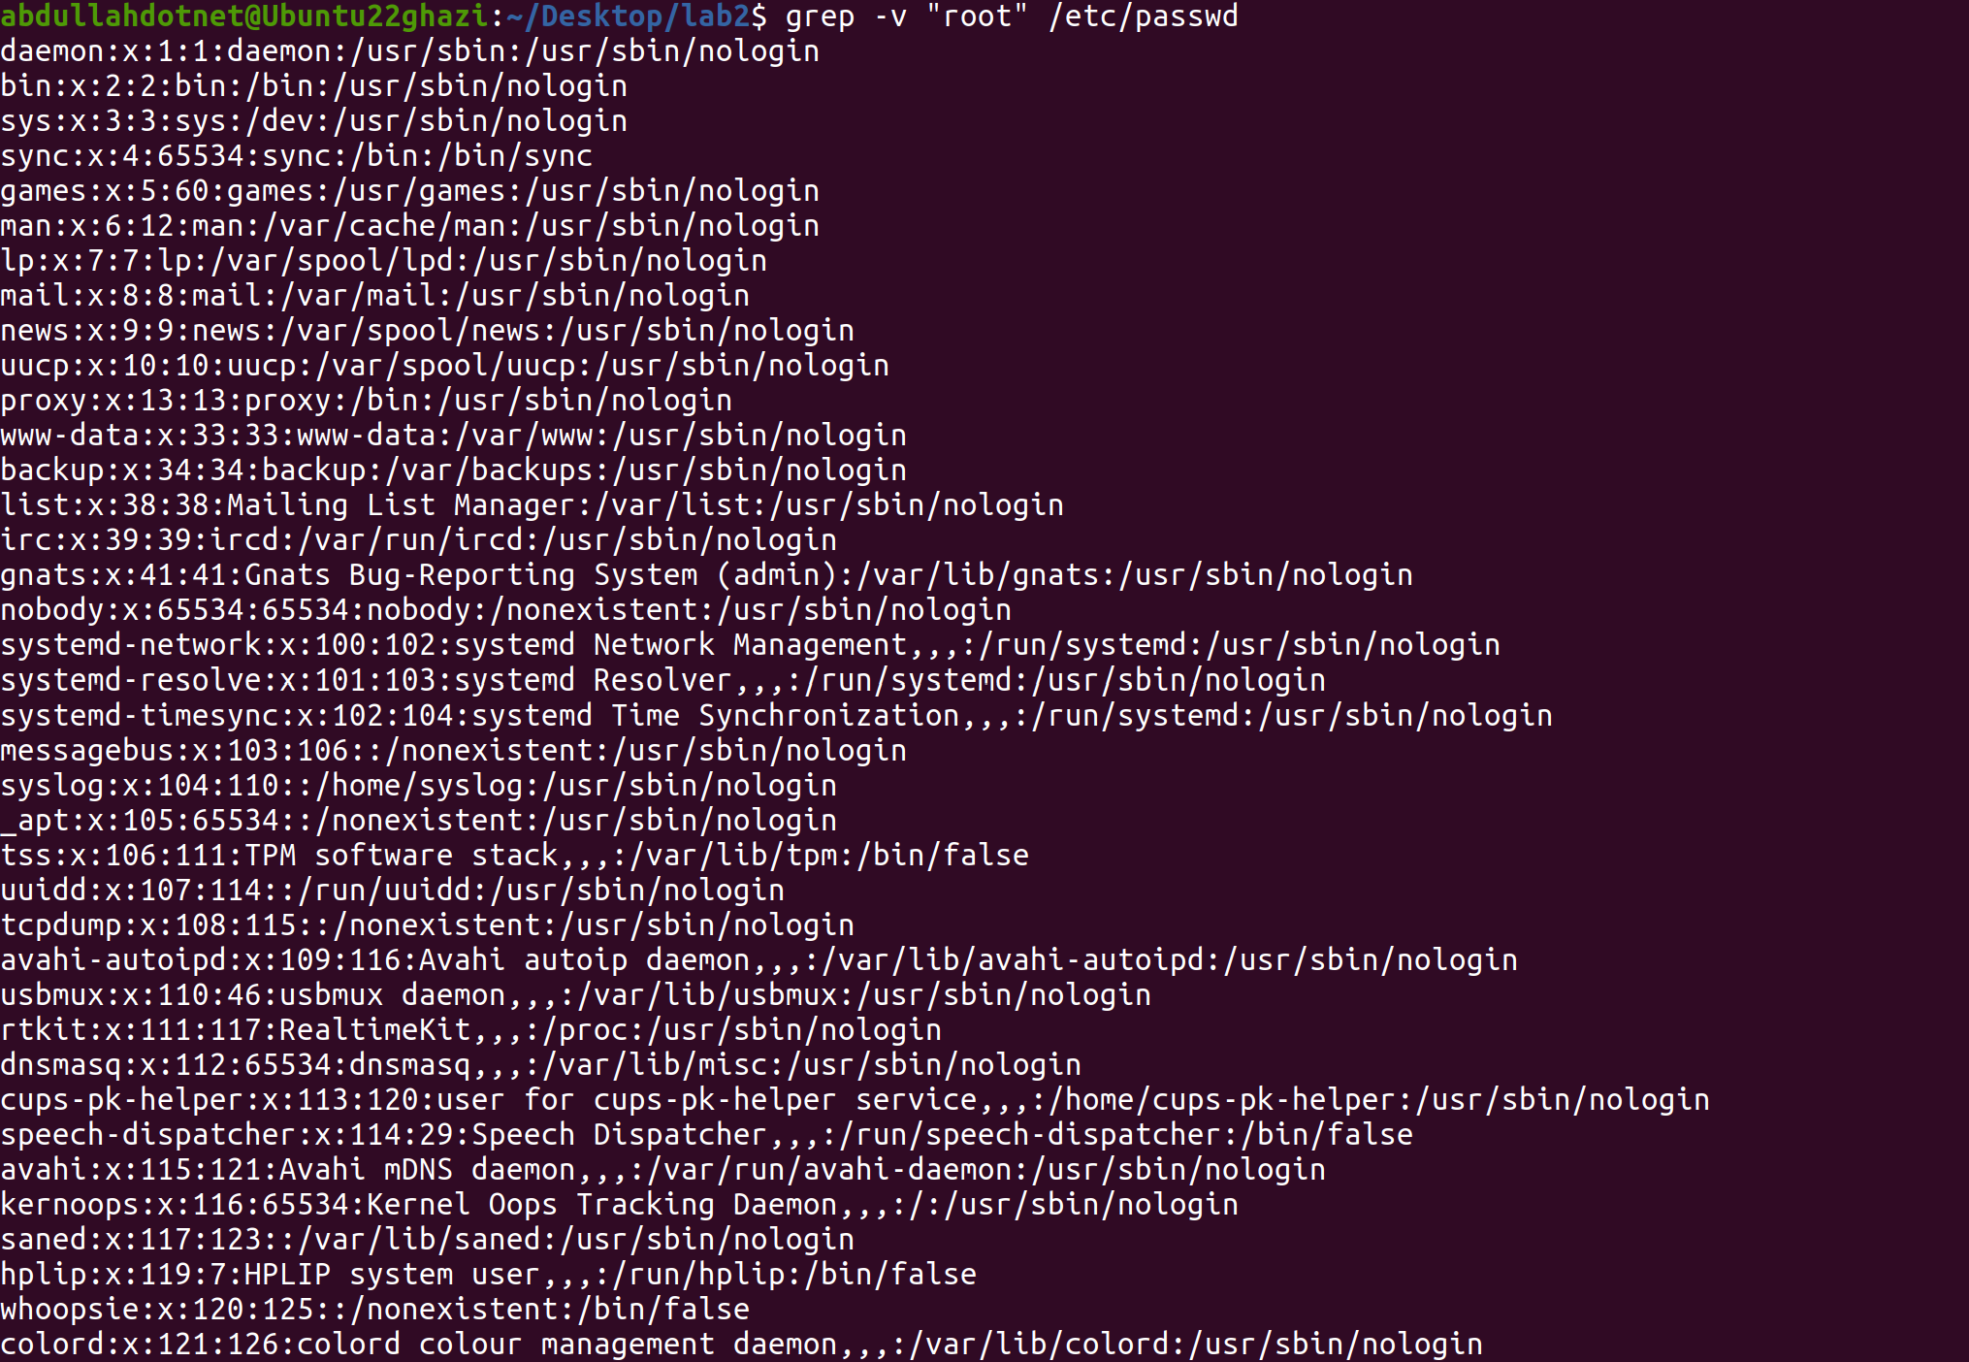

## Task 03:

Perform the following task

1. Write a command which take file “**/etc/passwd**” and display its 1st, 3rd and 5th column

awk -F: '{print $1, $3, $5}' /etc/passwd

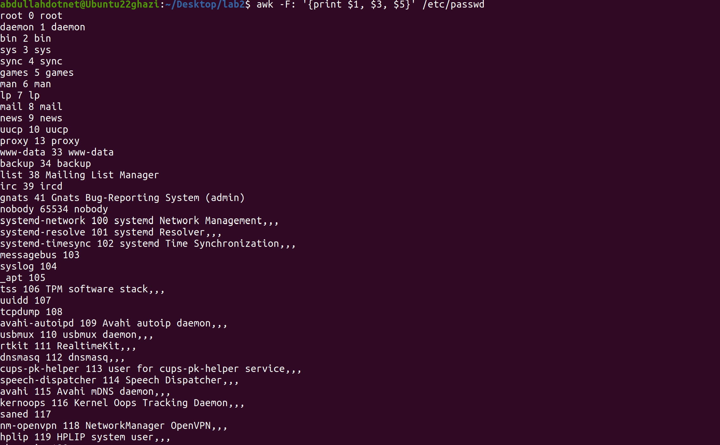

1. Try the –b flag with cut command and understand what it does.

echo "1234567890" | cut -b 1-5



## Task 04:

1. Try using **whatis**, **whereis**, which and **man** with argument **tar** and try to understand there usage.

i) whatis is giving one line description

ii) whereis locates the binary, source, and manual pages for a command or file.

iii) which shows the path of the executable that would be executed if the command tar were entered.

iv) man displays the manual page for a given command.

1. Print first 3 lines of **/etc/passwd.**

head -n 3 /etc/passwd

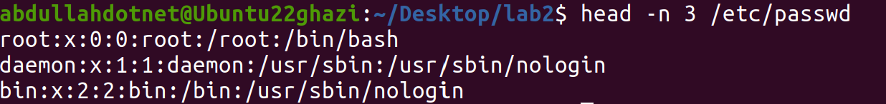

1. Print last 3 lines of **/etc/passwd.**

tail -n 3 /etc/passwd



## Task 05:

1. Write a command that will create an archive with the name of mywork.tar that contains all the files in the home directory of the currently logged in user that start with character a, and end with extension .c or .java. Then given a second command to compress the archived file with the name of mywork.tar.gz

tar -cvf mywork.tar ~/a*.c

gzip mywork.tar

